* Responsive: trên từng màn hình

/\* Extra small devices (phones, 600px and down) \*/

@media only screen and (max-width: 600px) {...}

/\* Small devices (portrait tablets and large phones, 600px and up) \*/

@media (min-width: 601px) and (max-width: 767) {...}

/\* Medium devices (landscape tablets, 768px and up) \*/

@media (min-width: 768px)and (max-width:991px) {...}

/\* Large devices (laptops/desktops, 992px and up) \*/

@media (min-width: 992px) and (max-width:1199px) {...}

/\* Extra large devices (large laptops and desktops, 1200px and up) \*/

@media (min-width: 1200px) {...}

* Nội dung

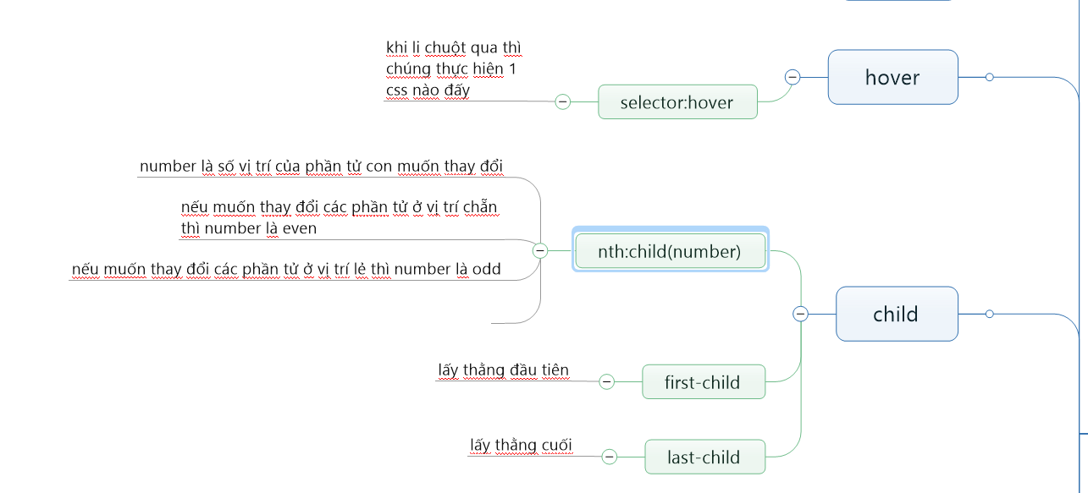

hình 1

